INCREMENT 4 TRUSTED NEWS TRIBUNE APP

Hari Sagar Velugula

Madhuri Kondepu Supriya Neeharika Gajula Rajesh Tummala

# The story for the project (problem statement):

**What Is Trusted News Tribune App?**

**News:** According to Oxford dictionary “newly received or noteworthy information, especially about recent or important events usually a broadcast or published report not previously known to a someone.” This can be done in a variety of ways, including word of mouth, postal systems, printing, electronic communication, broadcasting, and the testimony of event watchers and witnesses.

**History of digital news:** A initiative established by media firm Knight-Ridder in 1983 was one of the early forerunners of internet news. It was one of the first systems to transmit electronic news straight to readers, allowing consumers access to stories before the paper arrived on their doorstep the next morning. It was dubbed Viewtron. However, the expenses were high, and it necessitated the use of a specific keyboard and terminal. Despite gaining a few thousand members, Viewtron was too much ahead of its time in terms of technology.

## Evolution of digital news:



**The people who are facing the issue with mass information:**

Every day, people consume vast amounts of information on the internet, with about 40% of worldwide internet users reading news online. This, of course, has an impact on their expectations of news websites. According to a joint survey conducted by the Broadcast Audience Research Council of India (BARC) and Nielsen India, time spent on news applications and websites has increased by 41%.

## Why Trusted Tribune News App?

Apps have been a must-have for enterprises since the introduction of the smartphone, and publications have followed suit. People want to read on the go, and the easiest way to do it on a mobile device is through applications. This has allowed newspapers to reintroduce charging, with subscriptions for the majority of them. There are, however, a handful that provide free applications. Readers may consume news with images in the same way as they would on the internet. The difference is that the applications contain a lot of ads, information which might drain the battery.

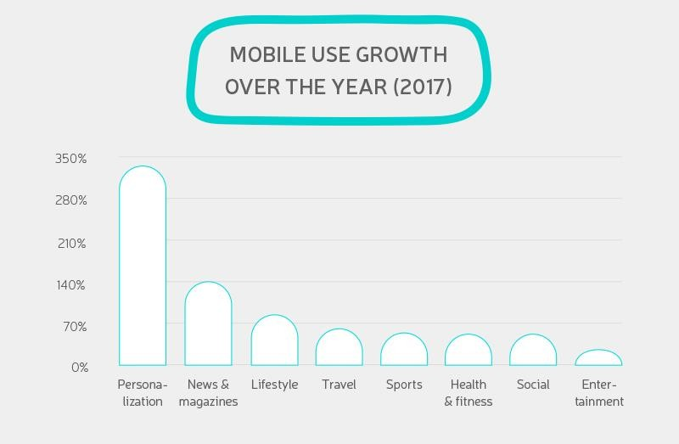

In this report we are going to discuss about **Trusted News Tribune App & website.**

**Trusted News Tribune & Website** is a news website and service that provides editors- selected news headlines and stories. Top stories, US, global, money,

crime, technology, sports, entertainment, and opinion as well as other interesting items, are all covered in the app.

# What Is this Trusted News Tribune app For?

Magazines and newspapers are no longer the only sources of information. In reality, the media landscape has changed dramatically. Like two-thirds of Americans, you can read postings on Medium, where anybody can publish their experiences, explore aggregators like Smart News that bring together items from many sites, and locate digital news amid other posts in your Facebook feed. However, all of these platforms, particularly social media, are filled with bogus news and clickbait. Remember Facebook's false news scandal,

and you'll understand why more than 71 percent of Americans distrust social media, while just 36% trust newspapers.



As the name suggests, this app also promises no false news and up to the minute news to the readers.

# What Problem Does this app Solve?

What crimes the media chooses to cover and how they cover them can have an impact on the public's view of crime, including how much crime happens in particular neighborhoods and cities. Editors and assignment editors make difficult judgments regarding which criminal tales to cover (or not) and what to call the story. Journalists and reporters, in collaboration with their assignment desks and producers, decide what information about the crimes they will include or exclude, as well as which experts they

will consult, what quotes from that expert they will include, and where these facts and quotes will appear in the story. Other media executives decide on the piece's importance in the newspaper or on the news program. The process through which the media determines whether to report on crime is extremely complicated.

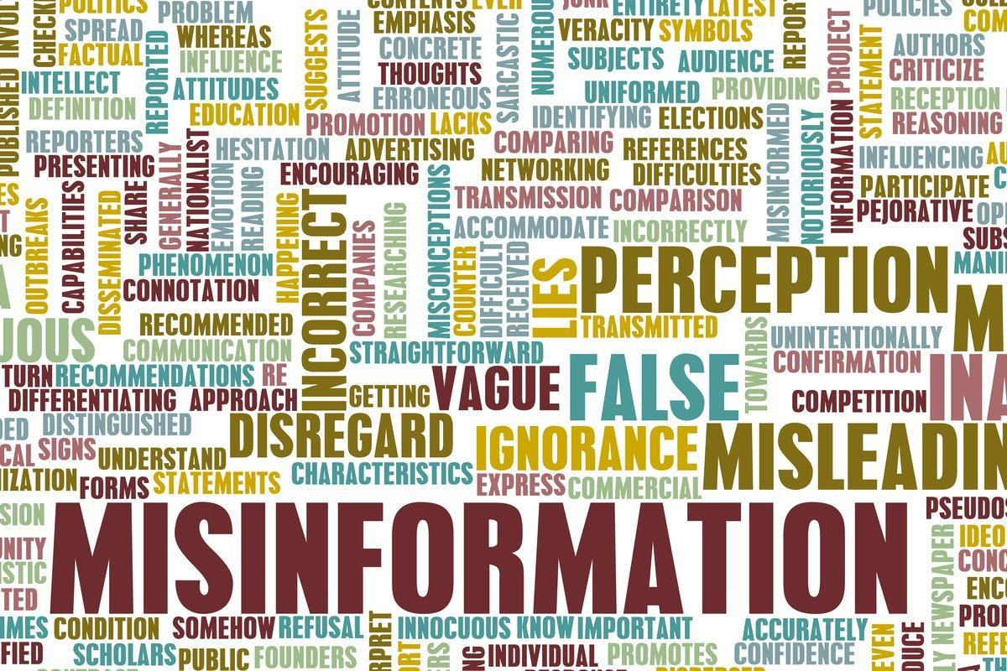

.

Along side providing trusted news, this app can also focuses on lot more features as follows:

1. Offering personalization
2. Faster updates of news
3. Utilization of mobile app’s native features
4. Push notifications
5. Quick share
6. Offline download feature
7. Guest content
8. Interaction with users

# What Design Principles Underlie Trusted News Tribune app ?

As we all knew that, costing always depends on features we want, and features can be unlimited, so we need to carefully decide what to keep in an initial stage and what the features which we can neglect are.

Over here, I’m listing some generic features list which is must require in any news app.

**User App:-**

Sign up & Login

Forgot and change password Create profile

News feed on home screen

Push notification Subscription feature

Invoice history (if paid feature is available in the app) Advertisement feature where user can put the advertising

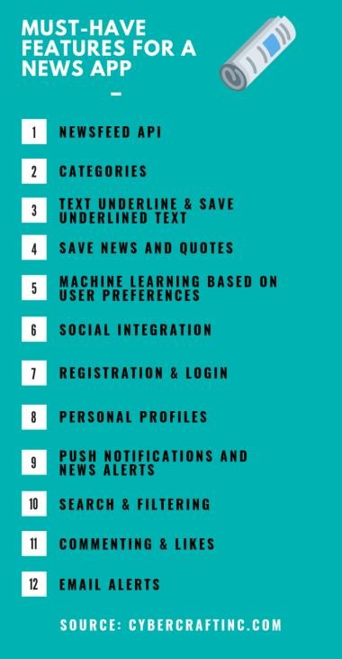

# How Does the app Accomplish Its Goals?

Our aim has been to keep you informed in an easily accessible, thorough, and reliable manner. From a design standpoint, news websites can be fascinating to explore. Whatever type of news they cover, they all face the issue of displaying a large volume of content on the main page, which presents the designer with several layout, usability, and navigational challenges. Examining how news websites deal with these issues can teach us a lot about how to deal with them. This news app also fetches the content from different sources and gives the correct information according to personalization of a user.

**Steps Involved in the work-flow of project:**

## We have mainly concentrated on the below features.

## User App:-

Sign up & Login.

Choose type of news they like. News feed on home screen.

Logout from the website.

**Tools used for this Project:**

In order to build our news aggregator app, we will be integrating Django with other technologies. Below are the libraries that play a key role in developing the app:

* Beautiful soup
* Requests module
* Django Framework

**Beautiful soup:** Beautiful Soup is a Python library for parsing HTML and XML files and extracting data. It integrates with your preferred parser to enable fluent navigation, search, and modification of the parse tree. It is typical for programmers to save hours or even days of labor.

Here in building our app, we are **Web Scraping** using Beautiful soup. So now, what is Web Scraping? Scraping data from the internet with various tools and frameworks is known as eb Scraping. It's sometimes used to track online pricing changes, compare prices, and evaluate how well rivals are doing by scraping data from their websites.

**Requests module:** When you're working on the internet, whether for business or leisure, you're bound to seek for some information. Or you may also utilize a website to watch movies, publish data, or check social media. To gain access to all these Internet resources, you must submit a request to the Internet server using your browser.

**Django Framework:** Django is used for building safe and maintainable websites quickly. Django is an open-source backend web application framework built on Python.

Simplicity, dependability, adaptability, and scalability are the key objectives. Django comes with a dynamic CRUD (create, read, update, and delete) interface that may be customized with admin models and produced using introspection. The acronym CRUD refers to the fundamental database operations, which implies the interface makes it easy to view, change, and search for data.

**CodeWork of our project is as follows**

The outputs of the project is as shown below

# Work sharing/Module sharing between teammates:

**Rajesh &Hari Madhuri supriya**

Checking the websites which can have access for scraping.

Writing API based on the article after inspecting the page source.

Working with the UI and sign in forms .

**Improvement from the previous increments:**

In the previous increments we have faced the crashed cookies and we done it manually. We resolved the issue by this increment. Changed some UI too.

# Issues and blockages with the project:

One issue we are facing right now is deployment of project in to the cloud.

## References:

[**https://careerfoundry.com/en/blog/data-analytics/web-scraping-guide/**](https://careerfoundry.com/en/blog/data-analytics/web-scraping-guide/)[**https://pypi.org/project/beautifulsoup4/**](https://pypi.org/project/beautifulsoup4/)

[**https://data-flair.training/blogs/django-project-news-aggregator-app/**](https://data-flair.training/blogs/django-project-news-aggregator-app/)

**Video explaination of project is provided below**

<https://youtu.be/bXhvgp8r7V0>

**GitHub link for the project:**

<https://github.com/mk9tmmadhuri/demooo/tree/main/project/DataFlair-News-Aggregator>

**Presentation link for the project:**

<https://github.com/mk9tmmadhuri/demooo/blob/main/project/NewsTribune1%20(1)%20(3).pptx>